School Counseling Program Newsletter
Shandrai Silva, School Counselor | October 2017
Counselor Message  Happy Fall! The school year has gotten off to a fantastic start! In September, we celebrated International Dot Day again this school year. Students had a wonderful time learning about themselves and making their mark in guidance classes. Our Make Your Mark service project was a huge success! Together, we collected almost 690 items for Gaston Hospice. We also recognized International Day of Peace in September by wearing white and students learning more about peace and how to be Peacemakers in guidance. Students participated in their first social – emotional lesson from a new curriculum adopted by Gaston County School.  October is going to be another great  month at Hawks Nest! Classroom  guidance lessons will continue and  small group planning is underway.  See Look What’s Happening for other  school counseling program news.  How to see the school counselor  Classroom guidance classes, based on grade level specials schedule, are either weekly or bi-weekly. Small group counseling and individual counseling by self -referral, parent referral, teacher referral, administrator referral or counselor initiated.  Contact School Counselor at 704-866-8467or sosilva@gaston.k12.nc.us. | Home of the Hawks  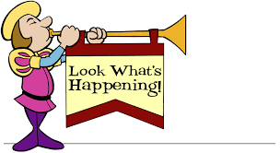  Bullying Prevention Month  This month we focus on continuing to promote a culture of kindness and respect. Unity Day is Wednesday, October 25th - wear orange to show  your commitment to ending bullying everywhere.  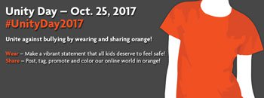  Red RibbonWeek  October 23-27, 2017  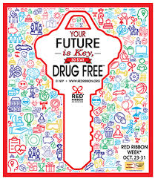  A week focused on healthy living through guidance lessons, Spirit Week and Door Decorating contest. | Character Education  “We’re Soaring with Good Character”  ______________________________  The character trait of the month is Fairness. Fairness is taking turns, sharing, and listening to what others have to say; treating others respectfully.  ___________________________________  Promoting Character Education  “Fairness does not mean everyone gets the same. Fairness means everyone gets what they need.” - Rick Riordan  Long Story Shortz – Fairness  https://www.youtube.com/watch?v=rcuBRKrIYlA  